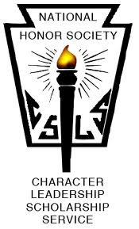

COLTS NECK HIGH SCHOOL McCHESNEY KANE CHAPTER

NEWSLETTER
February 7, 2019

1. Meeting dates:
Mar. 7th Mtg (am and pm in Auditorium)
Apr. 4th Mtg (am and pm in Auditorium)
May 2nd Mtg (am and pm in Auditorium)
May 3rd Executive Board Elections for Juniors
June 6th NHS Breakfast & distribution of medals

2. Bowling Fundraiser
When: Thursday, March 14th
Where: TBA
What: Get your friends and come bowl for two hours, 7-9pm.
Why: To have fun! Plus prizes will be awarded to top scoring individuals and teams.

3. 5k Color Run is on May 18, 2018 (Rain Date May 19th)
- We need … runners /walkers! Sign up family and friends to participate.
- We need … sponsors! Distribute sponsor info to family and friends!
- We need … prize donations! Hit up local businesses and see if they are willing to donate prizes (e.g. gift certificates, etc)
- Race committee lunch meetings?

4. Do you know a fellow member of NHS who is doing great things? Volunteering his / her time and making a real difference in the community? We would like to celebrate that person, thank him/her for making a difference. Send an email to hlucarelli@frhsd.com or dniemierowski@frhsd.com to nominate this person and include a brief explanation of this person’s accomplishments. Submission deadline is February 28th.

LOOKING FOR SOME NHS APPAREL? ONLINE STORE OPENING SOON!

