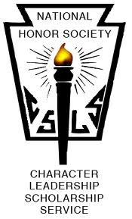

COLTS NECK HIGH SCHOOL McCHESNEY KANE CHAPTER

The purpose of this organization shall be to create enthusiasm for scholarship, to stimulate a desire to render service, to promote leadership, and to develop character in the students of Colts Neck High School.

NEWSLETTER
April 4, 2019

1. Volunteer opportunities to earn hours …
- Volunteer to tutor one day a week during lunch and earn one hour community service. Please see Mrs. Lucarelli in A134 or email hlucarelli@frhsd.com if interested.

- Roadside cleanup with Technology Student Association on April 9 at 3:15pm. Guaranteed 3 hours community service if you stay until the end. Please see Mr. Niemierowski in D103 or email dniemierowski@frhsd.com if interested.
- Adelphia School PTA is looking for volunteers to work their gift auction on Thursday, May 2nd from 6:15-10pm. If interested, please see Mrs. Lucarelli.

2. Important Dates …
April 30th Deadline for submitting Letter of Intent if running for Executive Board position
May 2nd Mtg (am and pm in Auditorium)
May 3rd Executive Board Elections for Juniors
May 10th Deadline for ordering NHS Medal to be worn at graduation
May 18th: Chase the Rainbow5k Color Run
June 6th NHS Breakfast & distribution of medals

3. Opportunities to satisfy Chase the Rainbow 5k Color Run obligation …
- Register to walk or run on May 18th
Complete
1
- Secure donations from local businesses of $250 or more
- Stuff goody bags
- Course markers
- Color throwers (day of)
- Volunteers for bag distribution area (day of)
- Volunteers for clean-up duty (day of)

4. Executive Board Elections…
- Executive Board positions are: One President, Two Vice Presidents, Two Secretaries
- If interested in running for an Executive Board position, please write a Letter of Intent stating the position you are running for and why you are qualified for the job. Submit to Mrs. Lucarelli or Mr. Niemierowski by Tuesday, April 30th.
- Speeches will be given at the May 2nd meeting. Candidates will present to members of the junior class for approx.30 seconds identifying why they are the best candidate for the job.
- It is MANDATORY for all juniors to vote in A134 or D103 on Friday, May 3rd between 8:00am-3:00pm. Please remember to sign-in on the attendance sheet to verify you voted!

5. Graduation Medals:
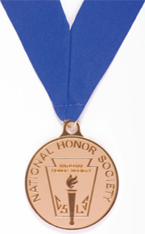
- All members of NHS will wear medals at graduation in June.
- Attention seniors: Please complete order form and submit to Mrs. Lucarelli in a134 or Niemierowski in D103 indicating your preference. Should you wish to purchase a medal, please make checks payable to CNHS NHS. Order forms and money are due by Thursday, May 10th. Your options are:
BUYING the medal for $25 and keeping it
OR
BORROWING the medal and returning at the conclusion of graduation
(in exchange for diploma)

